Title: Nuclear Reactions Impacting My Life
Course Title: Introduction to Chemistry (required, semester course)
Grade Level: 9th
Time: Four class meetings (three are 45 minutes, one is 75 minutes) over a 1 week period
Resources, Materials, Technology:
- Students use their own laptops to research online (one to one laptop school).
- PowerPoint and Microsoft Publisher are used to create the infographic.
- Infographics are converted to PDF files.
- Microsoft word is used to create the MLA Work Cited document.
Standards addressed:
- NGSS Practices: 2,6,7, 8
- NGSS Crosscutting concepts: Stability & Change,
- Scale, Proportion & Quantity, Energy & Matter
- NGSS DCI: HS-PS1-8,HS ESS1-1
Learning Objectives/ Outcomes:
- Students will understand where nuclear reactions take place which have a potential impact on their own lives.
- They will be able to characterize them as arising from nuclear fission, fusion or radioactive decay.
- They will be able to describe the risks and benefits of using nuclear reactions.
- Students will represent their understandings about nuclear reactions using an infographic which contains images, statistical information in the form of graphics and minimal text.
Previous lessons on which this builds:
- Students, in the Atom unit will have learned about the nucleus of an atom and how different isotopes can exist of the same element.
- In a previous lesson in the current, Nuclear, unit the students will have been introduced to the three main types of nuclear reactions: radioactive decay, nuclear fission and nuclear fusion.
- Students have been trained in a required Digital Literacy course in how to carry out online searches, how to use Microsoft Word, PowerPoint and Publisher.
- Google docs and Google slide have also been introduced to the students and many choose to use this for sharing during group or team projects.
- Blackboard is used within the school to transmit files between teacher and student.
- Within this course previously the students have created line graphs and bar graphs.

Lesson Structure and Procedures:
Before the Lesson
- At the end of the prior day’s lesson on the three main types of nuclear reactions students participated in a class brainstorming session on nuclear reactions to list as many ways as possible in which nuclear reactions play a role in their own lives.
- Once the prior knowledge of the students on this subject is exhausted the student are allowed time to use their computers to investigate further topics to add to the class list.
- Using search terms such as nuclear, nuclear power, nuclear reactions, radioactivity, radiation, a variety of topics emerges. The goal is to have as many topics or more than the student groups in the class.
- This brainstormed list forms the backbone for the topic selection activity which takes place on Day 1.

Day 1: 45 minutes in length
- The focus of this period is the familiarization of the students with the project expectations.
- Students are introduced to the infographic assignment. They are given the list of brainstormed topic ideas along with the student direction sheet (attached).
- Students select a partner with whom they want to work on the project. Each team is given a number selected by random which determines their position in the choosing of topics.
- Student teams are called up by number to select their topic.
- Once each team has a topic, the format of an infographic is described by the teacher.
- Examples of infographics are presented. At this point only a vague sense of the format, designing of an infographic is held by the students.
- The details of the content needed for their infographic is discussed using the student direction sheet (attached) as a guide.
- Students are then given the remainder of the period to begin researching their topic.
- During this time the teacher circulates to each team to verify that they understand the task at hand and are making progress on collecting information.
- At the end of the period they are encouraged to continue their research for homework and to bring the results of their searches to class the next day.

Day 2: 45 minutes in length
- The focus for this class period is forming the connection between the students and the information that they are gathering.
- The class begins with a check point discussion where students are asked to share what they have learned so far about their topic. Each team is probed to describe how nuclear processes have been found to impact their own lives.
- Students are then shown how to carry out a search using Google to locate images which are copyright free and therefore able to be used on their infographic.
- Students continue working on their collecting of content and now images with the teacher available to discuss any area of concern.
- During this period the teacher circulates to each team to verify that they not only are collecting information but beginning to synthesize it into new understandings of how nuclear processes are impacting their own lives.
- At the end of the period they are encouraged to continue their research for homework and to bring the results of their searches to class the next day. They should arrive for class with all of the information and images that they feel they will need in order to create their infographic.

Day 3: 75 minutes in length
- The focus for this class period is the creation of the infographic itself.
- Students are shown examples of previously created infographics on other topics using the PowerPoint and Publisher format.
- The logistics of sharing pictures and information with their partner are discussed and worked through.
- Students are given the entire period to create their infographic; compiling their information, creating graphs of their statistics and then working on the artistic design and presentation format.
- Students are directed to continue working on their collecting of content and now images with the teacher available to discuss any area of concern.
- During this period the teacher circulates to each team to help with formatting and design issues that arise.
- At the end of the period students are reminded that the completed infographic, along with the MLA formatted work cited are due before 8 AM on the next class period. This will allow the teacher time to print out the infographics for the Gallery Walk which will take place during the next class period.
- Students are also reminded of the teacher’s availability to help with any issue which arises during the intervening days. (This project was set up to have a weekend of team work time available between the infographic work day and the Gallery Walk).

Day 4: 45 Minutes in length
- The focus for this class period is the presentation of the infographic by the student during a Gallery Walk which is in a Speed Dating format.
- The infographics are displayed on the walls in the hallway outside of the classroom by the teacher before the class takes place.
- The students are divided into two groups with one member of each team on each group.
- The first group will present their infographics, they are asked to go out in the hallway and stand next to their infographic. The second group will serve as audience members. They will each pair up with one of the presenters. Every two-three minutes the audience will circulate, in a pattern, to the next presenter.
- During the presentation time the teacher circulates to listen to the presentations and to gauge when the next shift should occur.
- After each presenter has been heard by the majority of the audience members, the audience switches to become the presenters and the presenters become the audience. The process of presenting then shifting begins again and continues until the majority of the presenters have been heard by each member of the audience.
- At the end of the period, or at the beginning of the next one if time has run out, the class has a recap of what was learned from this experience. Finally, the students are asked to vote for their favorite presentation. They are asked to explain why they made the choice that they did.

Student directions/handouts:
Nuclear Reactions Impacting My Life
Objective:
- You will understand where nuclear reactions take place which have a potential impact on your own life.
- You will be able to characterize them as arising from nuclear fission, fusion or radioactive decay.
- You will be able to describe the risks and benefits of using nuclear reactions.
- You will represent your understandings about nuclear reactions using an infographic which contains images, statistical information in the form of graphics and minimal text.
Student Directions:
- Working with a partner, you will choose one of the topics which resulted from our class brainstorming session to research. These are listed below.
- You and your partner will research your chosen topic and then prepare a one page infographic on that topic to present to the class during a gallery walk.
- Your research gathered and presented on the infographic should address the following questions about the nuclear process chosen:
  - What type of nuclear reaction is involved with the process being described?
  - How does the nuclear process work? Summarize in your own words how the process that you are researching takes place.
  - Which chemical elements, isotopes are involved?
  - Provide statistics or data on how much is used, how many are used, how often, how common it is.
  - How does it relate or connect to you, personally?
  - What should citizens know about this process in order to make informed decisions about its use? What are the Risks and Benefits involved?
- The answers to these questions, along with pictures to illustrate them are creatively composed into a one page infographic which is 8.5 x 11 inches in size. Microsoft Publisher is great for this. Make your infographic interesting and eye catching. The final infographic will be saved as a PDF and then uploaded through Blackboard.
- The sources of the information and pictures are cited on a separate word document which is also uploaded through Blackboard.
- The quality of the sources used for your information, the quality of the information presented and the quality of the infographic itself are all features which will impact your grade on this project. Specifics are detailed on the Specification Sheet.

Topic choices:
- The production of energy by the Sun
- The use of radiation to treat cancer
- The use of nuclear fission to produce electricity
- The Calloway County nuclear power plant: Nuclear energy in Missouri
- The possibility of using nuclear fusion to produce electricity
- The use of radiation in diagnosing diseases
- The difference between CT scans, MRI’s and X-Rays
- The use of nuclear fission in making nuclear warheads or bombs
- The concerns about nuclear wastes generated by nuclear power plants
- Nuclear catastrophes that have happened in the past: Fukushima
- Nuclear catastrophes that have happened in the past: Chernobyl
- To what extent is nuclear power currently being used in the US compared to other countries?
- What are the future plans for using nuclear fission to generate electricity in the US?

Specifications for the Nuclear Infographic
Content | 20 points means that the content listed is described completely and is understandable by your peers during the Gallery Walk.
What type of nuclear reaction is involved with the process being described?
How does the nuclear process work? Summarize in your own words how the process that you are researching takes place.
Which chemical elements, isotopes are involved?
Statistical information is provided graphically.
How does it relate or connect to you, personally?
What should citizens know about this topic in order to make informed decisions?
What are the risks and benefits involved?
Artistic Quality of the Infographic | 20 points means that the content listed is presented creatively in an organized manner that enhances the content.
The topic is presented clearly and succinctly
Students do not present material in question answer format, nor do they simply follow the organization of the questions given.
Pictures are either copyright free or student taken or created originals
Word art, images and graphs dominate the presentation. Text is kept to less than 10 words per text block.
Additional information and creative elements are included beyond those required.
Sources used | 5 pts.
Three sources other than the textbook are used and cited on a work cited document
The name of the source of the information used is cited beneath each text block or graph.
The sources used are credible and appropriate to the topic.
All images are copyright free and their source cited beneath the picture in font size 8.
Original artwork, images should be cited with the student name beneath the image.
DUE BY 8 AM. | Total = 45 points per partner (100 pts is the normal value of a test in this course)

Follow Up/Extensions:
- Student projects can be displayed in the school and viewed by the school community.
- Student projects could be written about in the school paper with examples given to illustrate and to spark a debate about Nuclear Power: Friend or Foe?
- Students can be asked to write a reflection on what they found most memorable about their own topic of research and why.
- Students can be asked to write a reflection on which of the topics presented by their peers was most memorable and why.
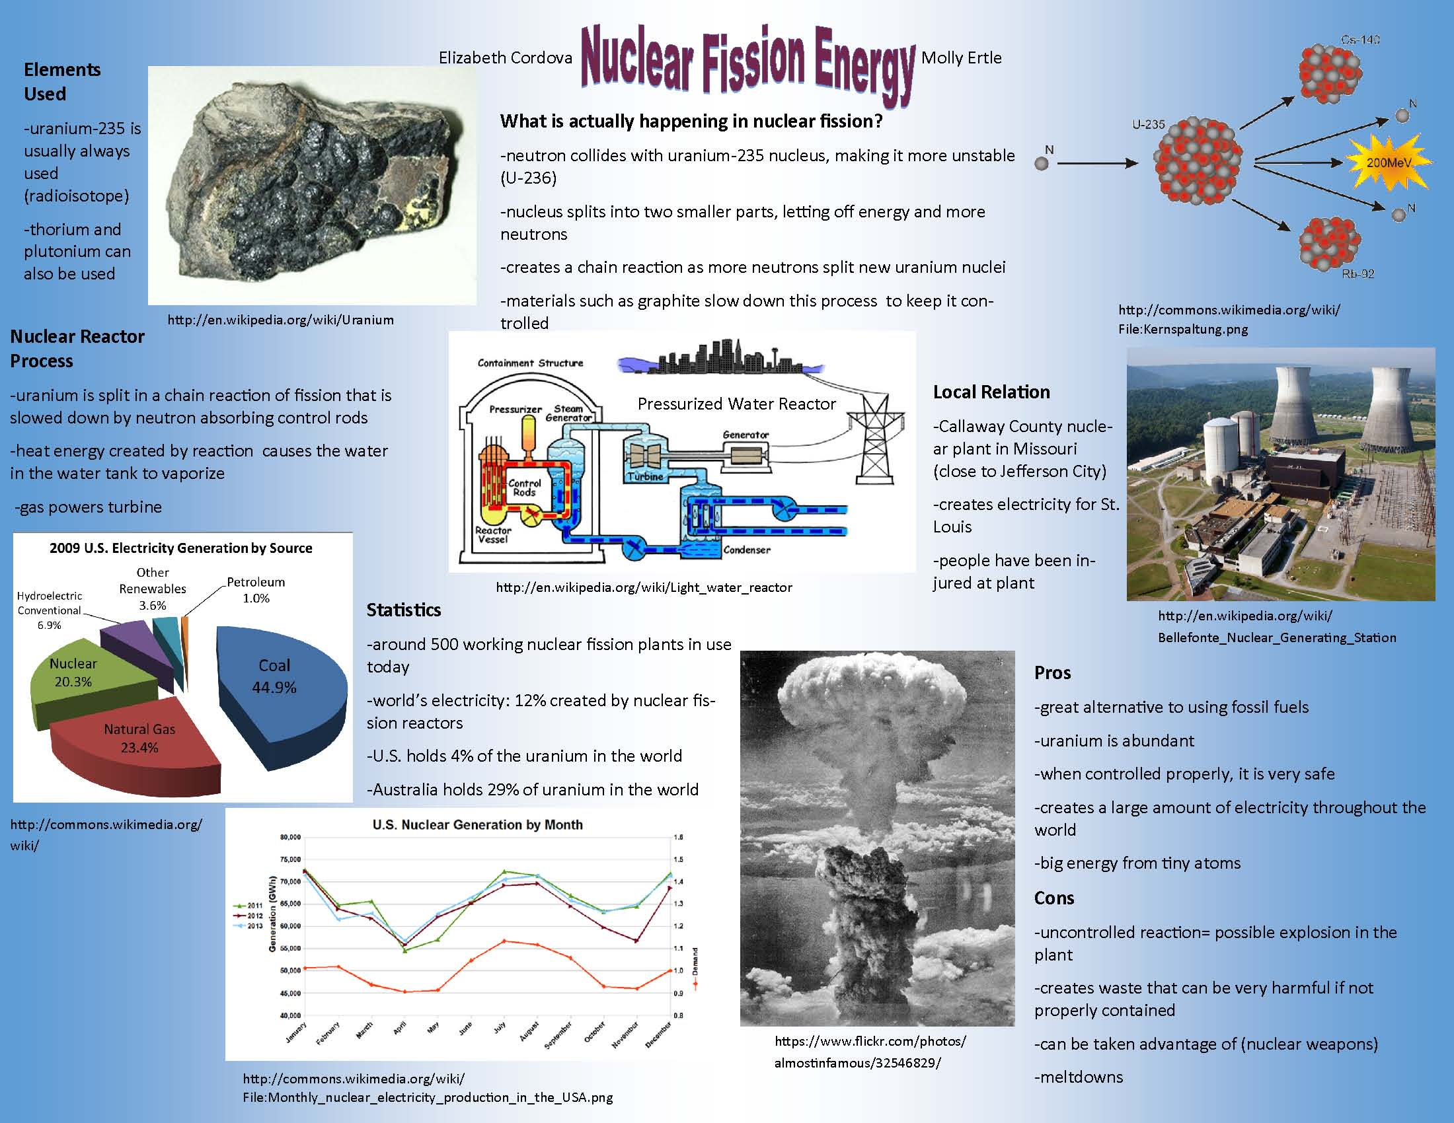
- Student projects on Nuclear Reactions can be discussed within their Social Studies courses with citizen involvement as the theme. Questions such as, “Should the US be increasing our reliance on nuclear power in order to decrease our reliance on fossil fuel?” could be posed to spark these discussions in the Social Studies course or as a follow up discussion in the science classroom.
Examples of student work:

