STEM Literacy through Infographics Venngage Teacher Guide
How do I get a premium educator Venngage account?
The SLI project has a project-wide license for Venngage which entitles all participating educators as well as their students to “premium” features in Venngage.
If you do not yet have a Venngage account:
Step 1: Send your email address to Joseph.Polman@Colorado.edu. You will then be sent an email when added as an educator onto the SLI account.
Step 2: Follow directions on the email. Go to https://venngage.com, and login.
If you already have a Venngage account:
Step 1: Send Joseph.Polman@Colorado.edu the username of your existing Venngage account (which is probably your email address), letting him know you already have an account. When your account is converted, you will then be sent an email when added as an educator onto the SLI account.
Step 2: Follow directions on the email. Go to https://venngage.com, and if you were already logged in to the system, log out and then log back in.

How do I add students to my education account?
Step 1: Go to the My Account page using the Account dropdown on the upper right
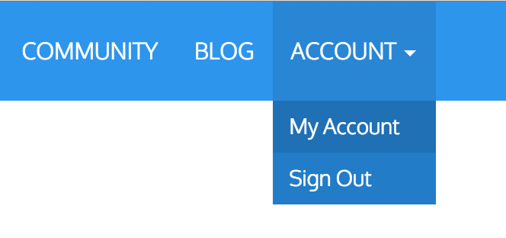
Step 2: Click on the My Class tab on the left to view your class's page
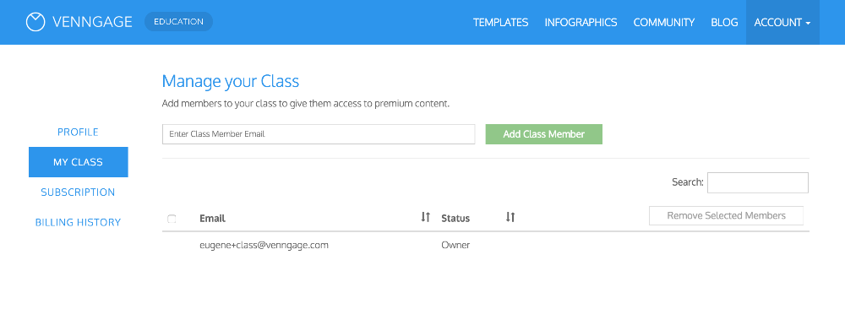Step 3: Add your student's email using the text box and click on Add Class Member. You can add new users or existing users. New users will receive an email with a link to create an account. Existing users will automatically have their accounts upgraded to Premium. (Existing users will need to log out and log back in to see the changes)
Note: If students have been entered into multiple classes using the same email, they may not be accepted. Teachers will have to delete students from prior classes before entering them into a new one.
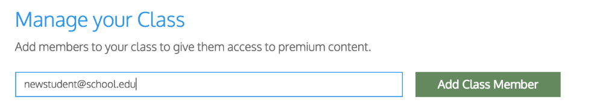
If you have lot of students and need help adding them to your class, you can send Venngage a spreadsheet with the emails which they will add for you. Please send email to support@venngage.com or use the Contact Us link on the website.

Step 4: Instruct students to log on to their emails and click the link to Venngage

